PHY101: Introduction to Physics-1
Monsoon, 2020

Tutorial-11

1. If a mixture of $n_{1}$ moles of monatomic gas and $n_{2}$ moles of diatomic gas has γ =1.5, then what will be the ratio of $n_{1}$ and $n_{2}$?

2. One cubic meter of atomic hydrogen at 0°C and atmospheric pressure contains approximately 2.7x10²⁵ atoms. The first excited state of the hydrogen atom has an energy of 10.2 eV above the lowest energy level, called the ground state. Use the Boltzmann factor to find the number of atoms in the first excited state at 0°C and at 10000°C.

3. At what temperature would the average speed of helium atoms equal (a) the escape speed from Earth, 1.12x10⁴ m/s and (b) the escape speed from the Moon, 2.37x10³ m/s? Note that the mass of a helium atom is 6.64x10⁻²⁷ kg.

4. A gas consists of molecules of mass m and is at a temperature T. Making use of the Maxwell velocity distribution function, find the corresponding distribution of the molecules over the kinetic energies Ɛ. Determine the most probable value of the kinetic energy Ɛ𝑝. Does Ɛ𝑝 correspond to the most probable velocity?

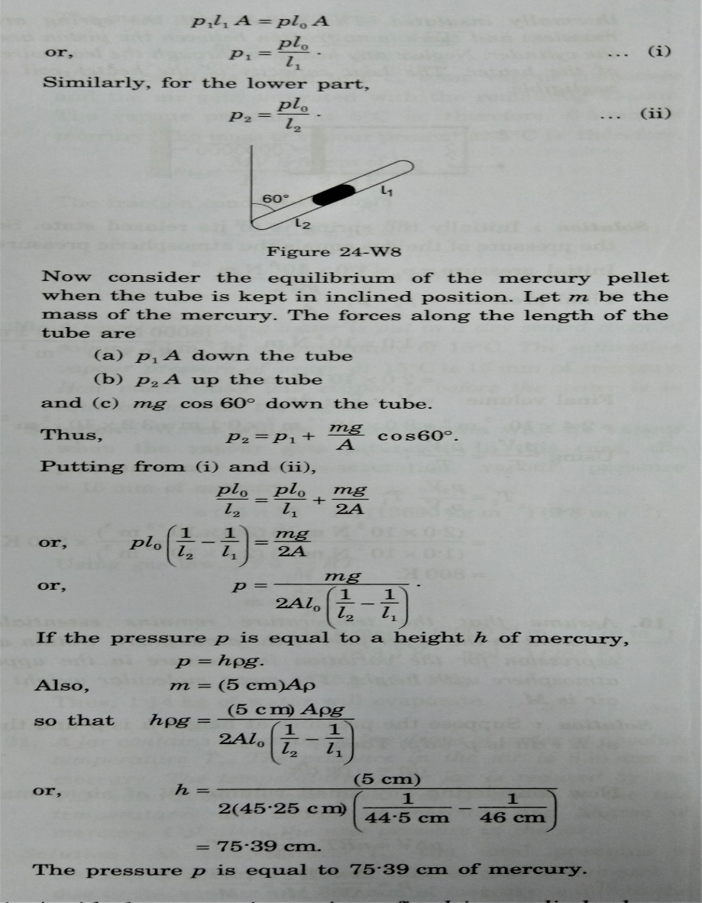
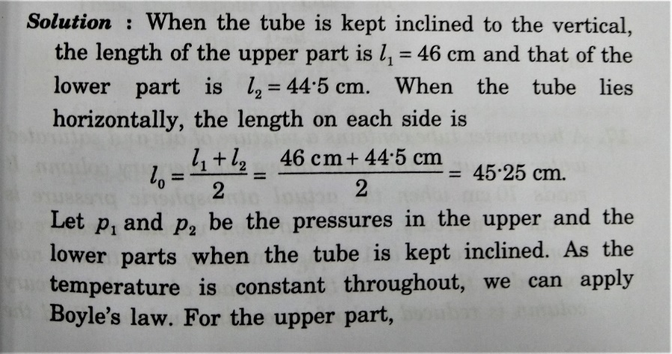
5. A thin tube of uniform cross section is sealed at both ends. It lies horizontally, the middle 5 cm containing mercury and the parts on its two sides containing air at same pressure p. When the tube is held at an angle of 60 degree with the vertical, the length of the air column above and below the mercury pellet are 46 cm and 44.5 cm respectively. Calculate the pressure p in centimetres of mercury. The temperature of the system is kept at 30 degree centigrade.

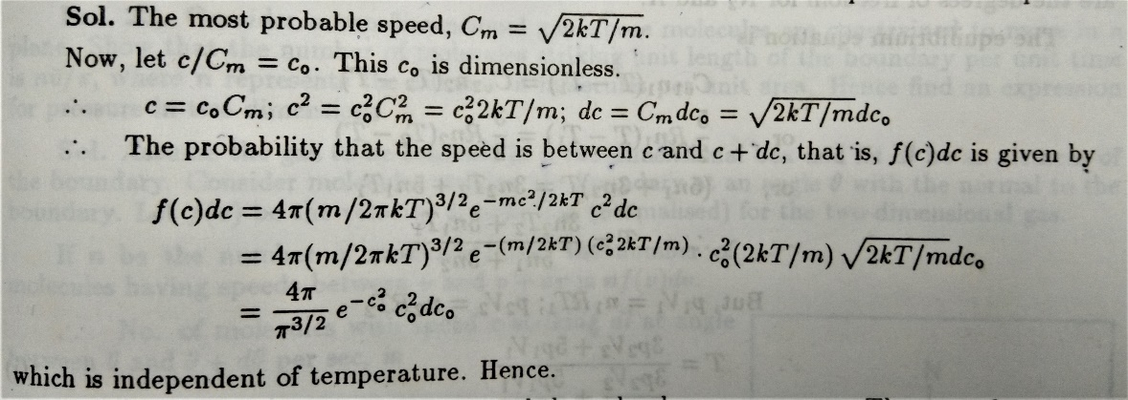
6. Show that if the most probable velocity (speed) is taken as unit of speed for gas molecules, the probability that the speed is between c and c+dc is independent of temperature.

